**Project Design Phase-I**

**Solution Architecture**

|  |  |
| --- | --- |
| Team ID | PNT2022TMID17579 |
| Project Name | Project – IOT Enabled Smart Farming Application |

**SOLUTION ARCHITECTURE:**

* Define features, development phases, and solution requirements.
* Provide specifications according to which the solution is defined, managed, and delivered.

**DIAGRAM:**

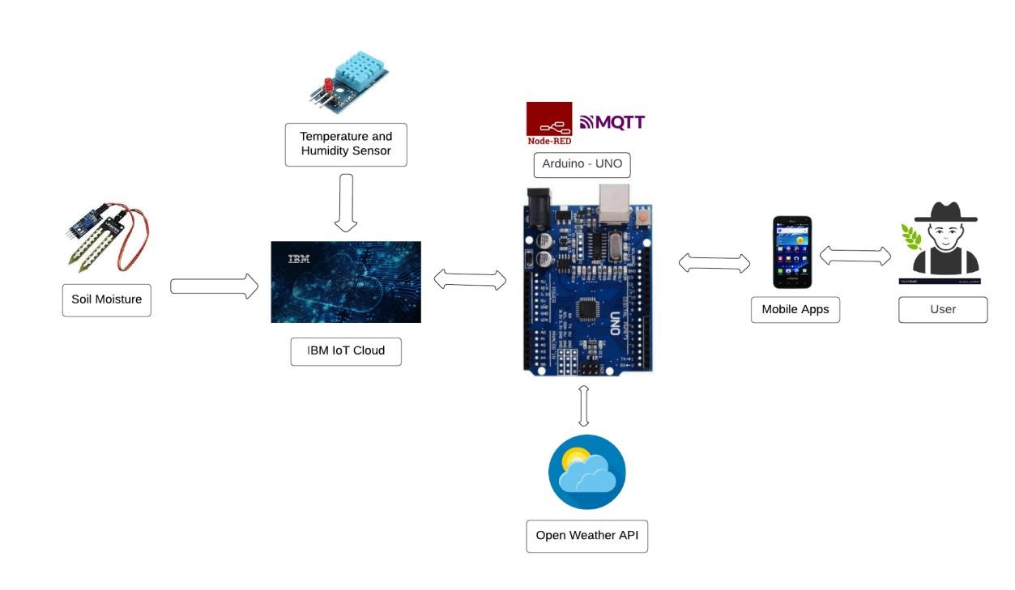

**SPECIFICATIONS:**

* Arduino UNO is used as a processing unit that processes the data obtained from sensors and weather data from weather API. The different soil parameters (temperature, humidity, Soil Moisture) are sensed using different sensors, and the obtained value is stored in the IBM cloud.Node-red is used as a programming tool to wire the hardware, software, and APIs. The MQTT protocol is followed for communication. All the collected data are provided to the user through a mobile application that was developed using the MIT app inventor. The user could make a decision through an app, whether to water the crop or not depending upon the sensor values. By using the app they can remotely operate the motor switch.